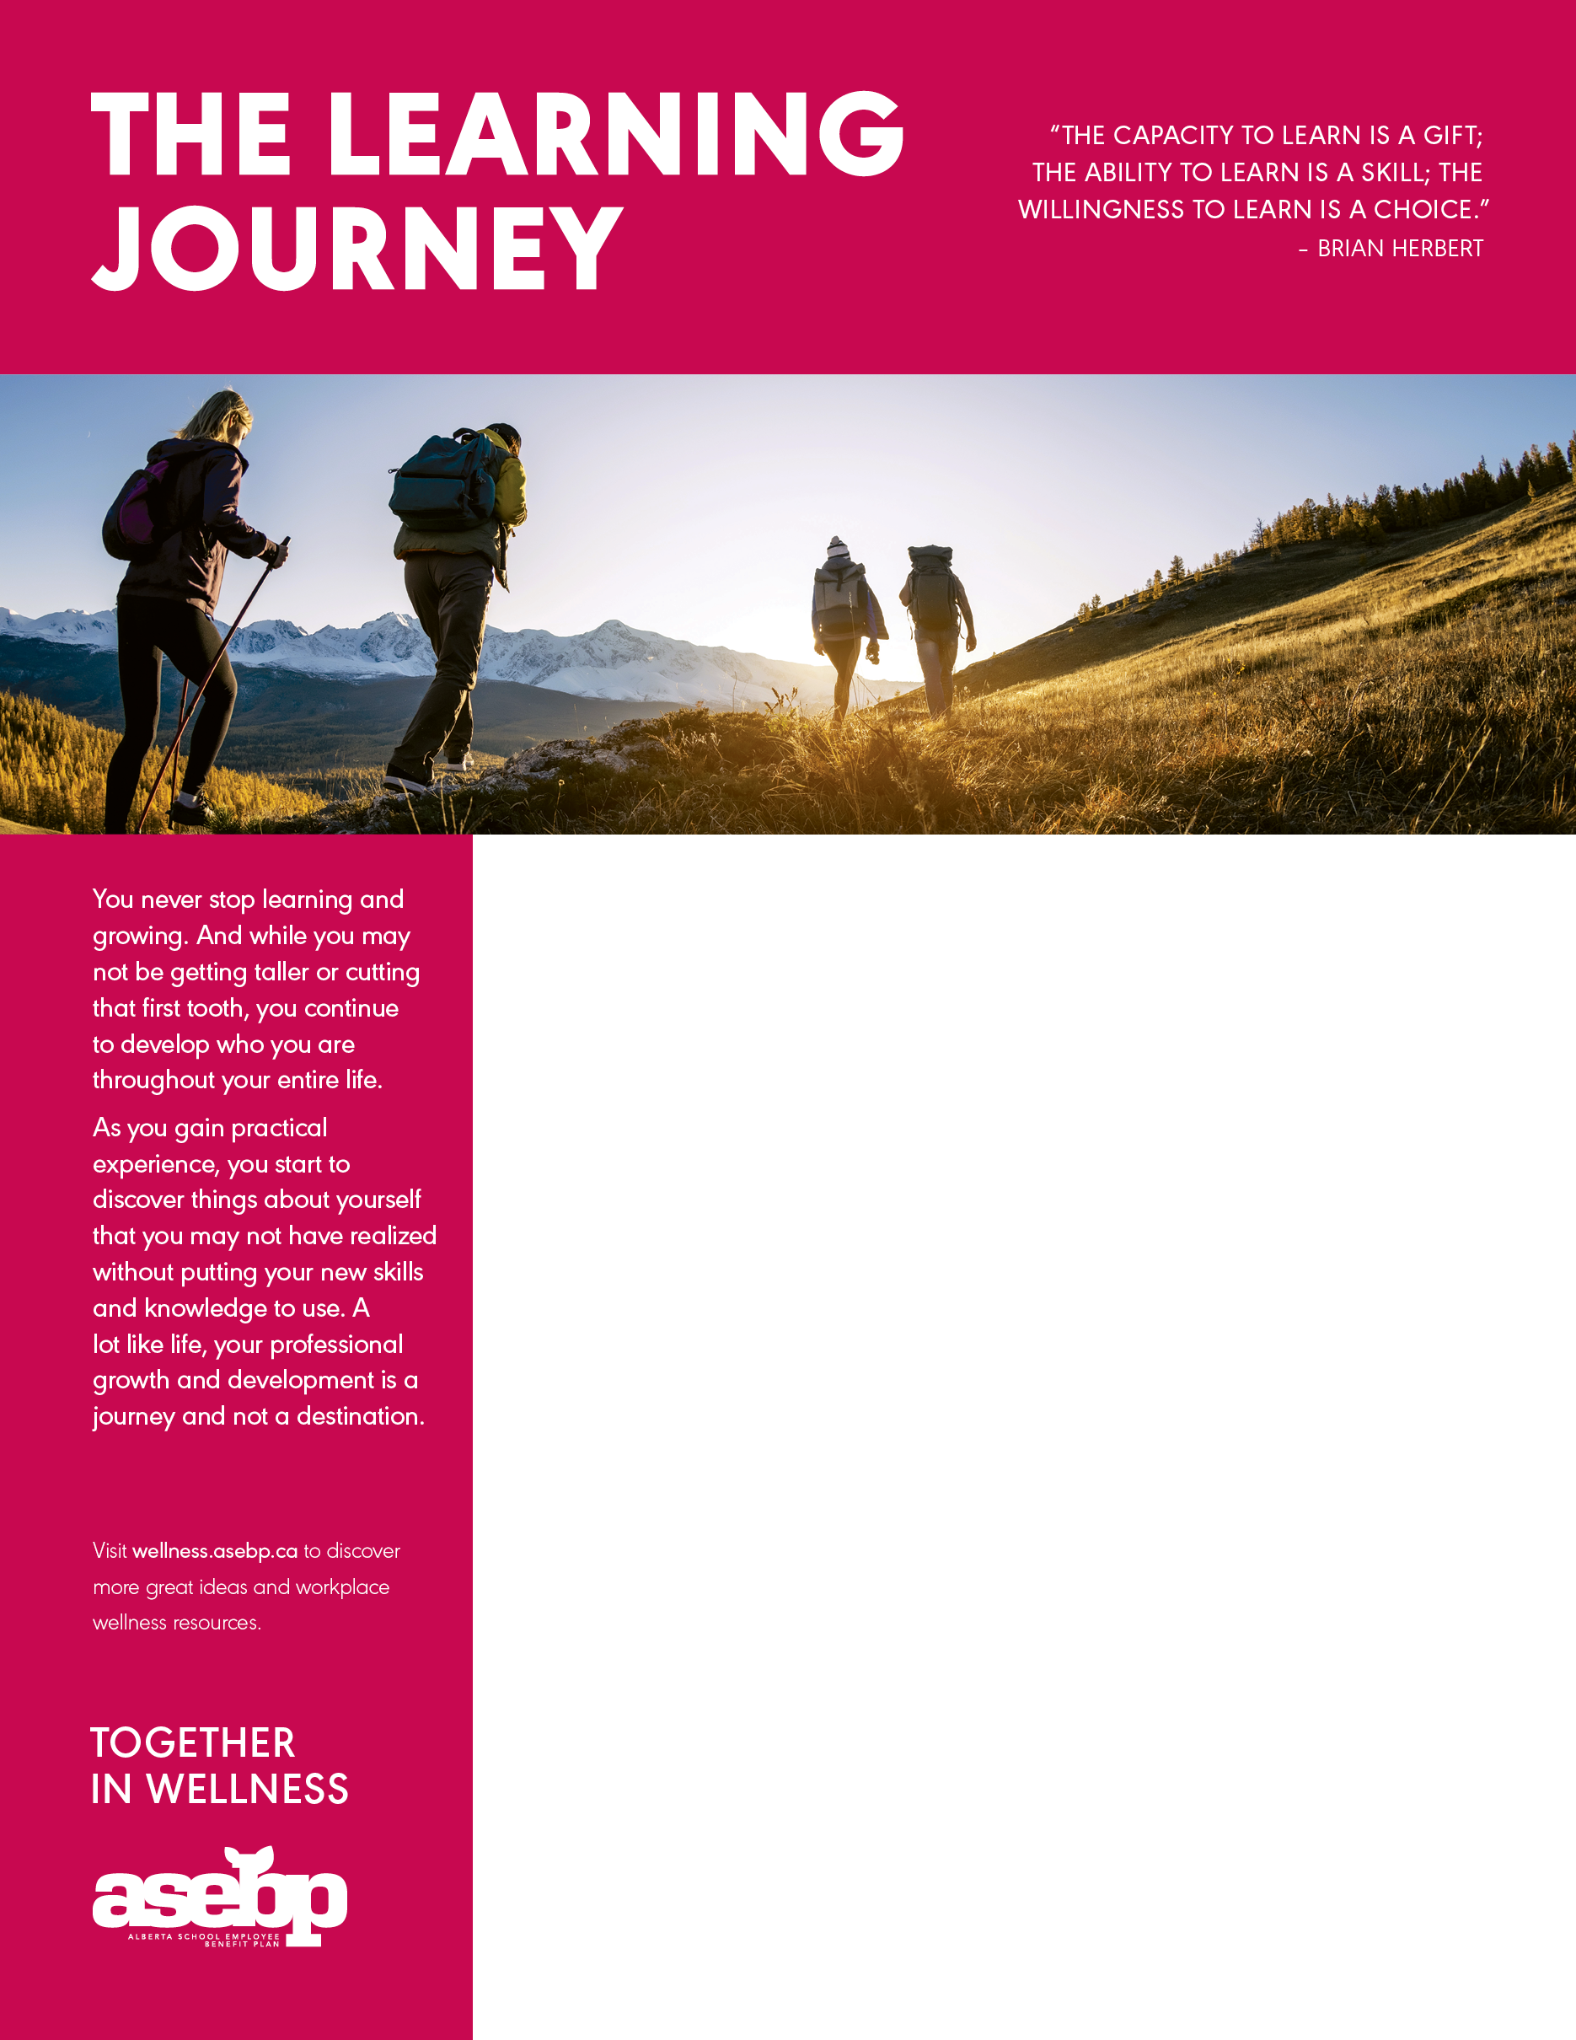

**ADD YOUR WORKPLACE WELLNESS TITLE HERE**

Add your workplace wellness information here! Here are a few ideas that you might include:

* Information about upcoming wellness initiatives or challenges in your workplace;
* Highlight services related to the theme, like your EFAP or ASEBP benefits;
* Share inspirational wellness quotes;
* Feature dates for wellness events happening in your community; or
* Browse through [wellness.asebp.ca](https://wellness.asebp.ca) for even more ideas!

RELATED RESOURCES:

**Infographic**: Malcolm Knowles’ *Adult Learning Theory* is based on the five assumptions and four principals articulated in this [infographic](https://roundtablelearning.com/resource/adult-learning-theory-infographic/).

**Support:** Interested in online learning? Check out [EcampusAlberta.ca](https://www.ecampusalberta.ca/)for a listing of online learning schools and training opportunities to help get you started.

**Website:** Whether you are looking for yourself or how to inspire and motivate others, [alis.alberta.ca](https://alis.alberta.ca/) has a variety of tools and resources, education and training options, and information on how to succeed at work.